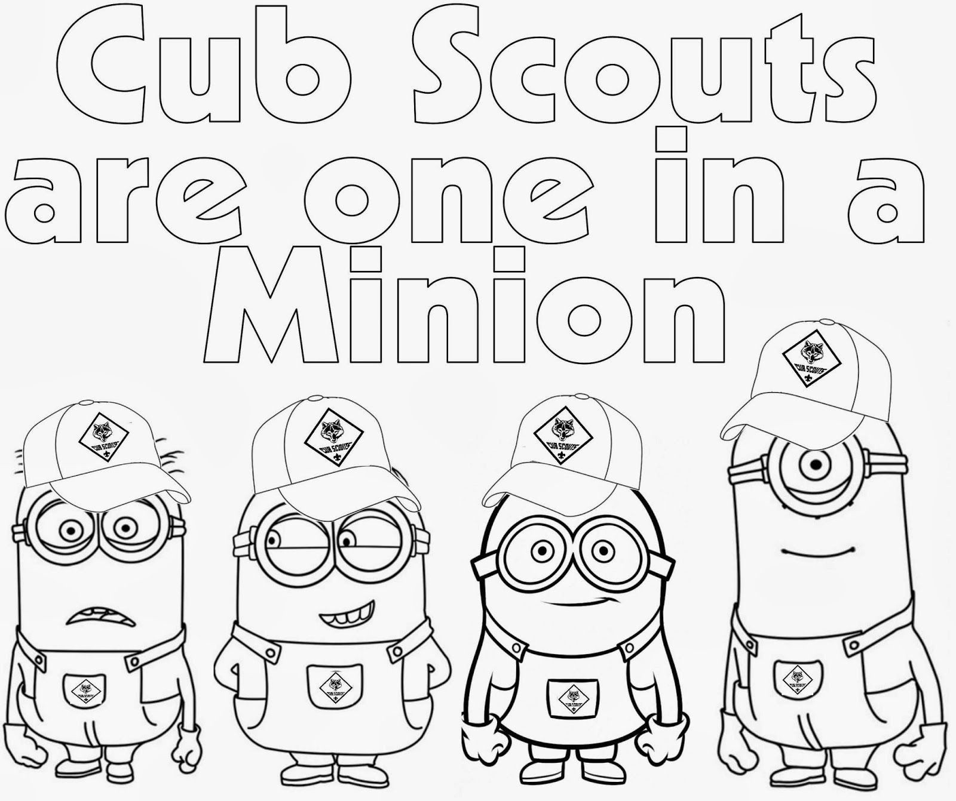

The Adventure STARTS TODAY

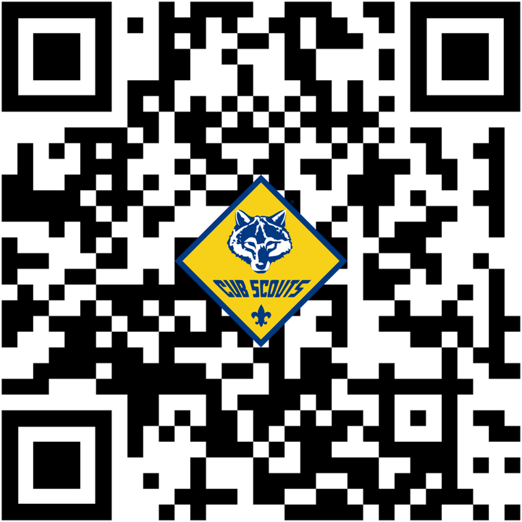

Visit BeAscout.org or scan the QR code
Learn what the Cubs Scouts Program and Join today!!
Scouting is family, fun, friends, and a lifetime of adventure! It’s the place where young people can grow to become their very best future selves.

