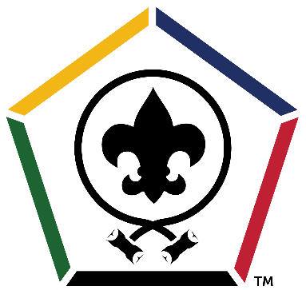
Twin Rivers Council
Wood Badge 2026
Course: 10-364-26
THE COURSE
Wood Badge is the ultimate leadership training program for adult volunteers in Scouting America, building on over a century of Scouting's finest traditions. It
integrates cutting-edge leadership models widely adopted by top corporations,
academic institutions, and leading public and private organizations.

This advanced program is tailored for all Scouters, both new and experienced, from Cub Scout leaders, Scoutmasters and their assistants, to Venturing Crew Advisors, Sea Scout Skippers, and Committee Chairs and Members. District and Council-level Scouters will also find Wood Badge invaluable for enhancing their effectiveness.

Through Wood Badge, participants gain essential skills in areas such as active listening,
effective communication, conflict resolution, strategic project planning, and leading
organizational change. The program also fosters a deeper understanding and
appreciation of inclusion and diversity. Ultimately, Wood Badge empowers Scouters to
become more capable leaders within Scouting, more successful professionals, and
more well-rounded individuals. The direct benefit is an improved and more impactful
program delivery for the youth that Scouting serves, thanks to highly trained and
effective leaders.

Wood Badge takes place over two weekends (you must attend both)

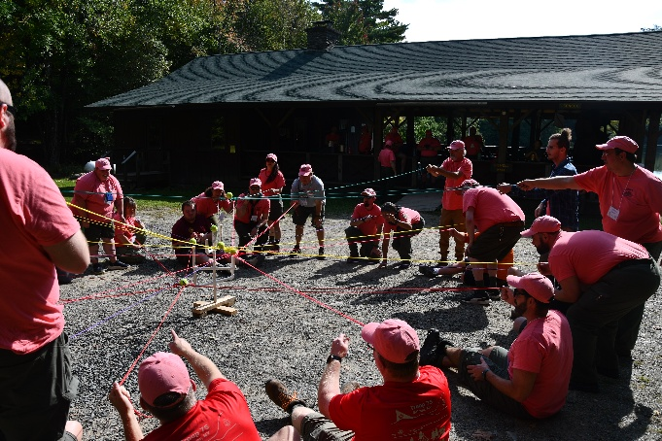
Dates & Locations:

Weekend 1 – August 28th – 30th
Weekend 2 – September 19th – 20th
Camp Wakpominee 185 Sly Pond Rd,
Fort Ann, NY 12827

Course Director:
Jeff Zemsky
518-847-4671
jeffzemsky@gmail.com
Course Details
Wood Badge is an exciting, high energy, and engaging time! Wood Badge courses sell out quickly! Your registration cost must be paid in full to guarantee your spot in the course. The first 48 participants paid in full will be guaranteed a spot.

To make the most of our time at Wood Badge there will be a set of online pre-sessions that will provide a solid background of what to expect. This will give the greatest amount of time to learn together, create new friendships, build new insights and methods to grow as leaders.

Come join the most fun adult Scouting adventure of the year!
Course Scholarships
Scholarships are available for those in need. We will be adding a link on the registration page to apply for aid.

Course Qualifications
- Be a registered Adult in a leadership position in Scouting America
- Complete your basic position specific training
- Have a complete Health Form (A, B and C) at the time of the course
