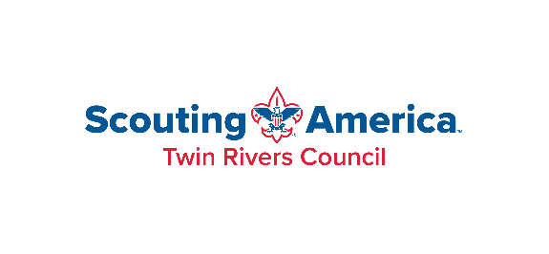

518-869-6436

Eagle Scout Reference Check Acknowledgement Form

This form must accompany the Eagle Scout Rank Application
submitted for review to the Twin Rivers Council

Troop/Crew _________ of the ______________________District hereby acknowledges that all references listed on the Eagle Scout Rank Application for Eagle candidate _____________________________have been personally contacted (verbally or in writing) by a member of the Troop Committee. Each reference has indicated that they have no reservations or concerns in recommending this Eagle Candidate for the Eagle Scout Rank. Details of any reservations or concerns are noted below.

Date _________
Troop Committee Chairman (print name)________________________________
Signature __________________________________________________________
Contact email address:_______________________________________________
Comments_________________________________________________________________________________________________________________________________________________________________________________________________________________________________________________________________________________________________________________________________________________________________________________________________________

Reference Check Acknowledgement Form 2/17/2026

